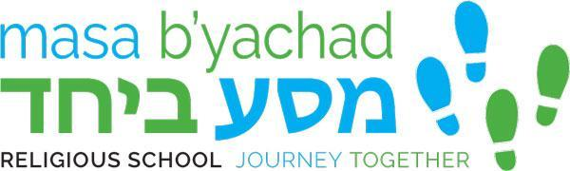

2022-2023 Calendar
September 7 - 1st day of Hebrew School
September 11 - 1st day of Sunday School
September 14 - Hebrew School
September 18 - Sunday School
September 21 - Hebrew School
September 25 - NO Sunday School - Erev Rosh Hashanah
September 28 - Hebrew School
October 2 - Sunday School
October 5 - NO Hebrew School - Yom Kippur
October 9 - Sunday School
October 12- Hebrew School
October 16 - Sunday School
October 19 - Hebrew School
October 23 - Sunday School
October 26 - Hebrew School
October 30 - Sunday School
November 2 - Hebrew School
November 6 - NO Sunday School - Fall Break
November 9 - Hebrew School
November 13 - Sunday School
November 16 - Hebrew School
November 20 - Sunday School
November 23 - NO HEBREW SCHOOL - Thanksgiving break
November 27 - NO SUNDAY SCHOOL
November 30 - Hebrew School
December 4 - Sunday School
December 7 - Hebrew School
December 11 - Sunday School
December 14 - Hebrew School
December 18 - Sunday School
December 21 - NO Hebrew School
December 25 - NO SUNDAY SCHOOL
December 28 - NO HEBREW SCHOOL
January 1 - NO SUNDAY SCHOOL
January 4 - NO HEBREW SCHOOL
January 8 - Sunday School
January 11 - Hebrew School
January 15 - Sunday School
January 18 - Hebrew School
January 22 - Sunday School
January 25 - Hebrew School
January 29 - Sunday School
February 1 - Hebrew School
February 5 - Sunday School
February 8 - Hebrew School
February 12 - Sunday School
February 15 - Hebrew School
February 19 - Sunday School
February 22 - Hebrew School
February 26 - Sunday School
March 1 - Hebrew School
March 5 - Sunday School
March 8 - Hebrew School
March 12 - Sunday School
March 15 - Hebrew School
March 19 - Sunday School
March 22 - Hebrew School
March 26 - NO SUNDAY SCHOOL - SPRING BREAK
March 29 - NO HEBREW SCHOOL
April 2 - NO SUNDAY SCHOOL
April 5 - NO Hebrew School - 1st Seder
April 9 - NO Sunday School
April 12 - NO Hebrew School
April 16 - Sunday School
April 19 - Hebrew School
April 23 - Sunday School
April 26 - Hebrew School
April 30 - Sunday School
May 3 - Hebrew School
May 7 - Sunday School
May 10 - Hebrew School

Sunday School - 27 Days
Hebrew School - 28 Days

